Lab 8

Sequential Circuits(State Machines)

RTL Modeling

(Datapath and Control)

Learning objective of this lab

* Describing a Digital System as Control and Datapath

The datapath comprises of registers and combinational circuits. The data proceeds through datapath based on control signals coming from controller

* In-Lab

**Task**

**Figure given below shows a numpad. When a key is pressed the connected line is set to 1, otherwise all the lines are at level 0. For example if 7 is pressed A=1 and E=1. Write the datapath for the previously described controller described by the state machine given**

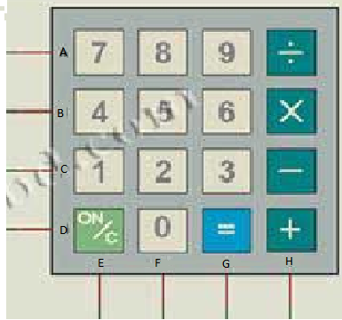

Figure Task1a

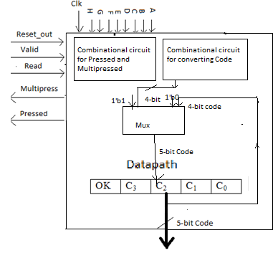

Figure Task1b

|  |  |
| --- | --- |
| Key | Code |
| 0 | 0000 |
| 1 | 0001 |
| 2 | 0010 |
| 3 | 0011 |
| 4 | 0100 |
| 5 | 0101 |
| 6 | 0110 |
| 7 | 0111 |
| 8 | 1000 |
| 9 | 1001 |
| + | 1010 |
| - | 1011 |
| x | 1100 |
| ÷ | 1101 |
| = | 1110 |
| ON/c | 1111 |

If Reset_out==1, Code=5’b0000

The 5-bit Register is assigned the code If Read is 1

The 5th bit (OK) is set to 1 if Valid is 1; else it is 0.

If a single key is pressed e.g. ‘8’ (code: ABCD=1000 and EFGH=0100) ; Set Pressed to 1

If more than 1 keys are pressed set Multipress and Press both equal to 1

* Combine the ControlNumpad(Previous Lab) and Datapath in a single Module.

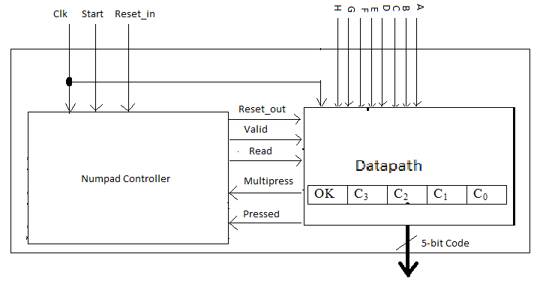

* Post Lab
* **Write the HDL description of Datapath for controller of a calculater.**

**The Ouput_to_Control vector= { Valid, AC_pressed, Equal_pressed, OpKey_pressed, counterlessthanlimit}**

**Input_from_Control vector ={ReadA, ReadB, Reset, Inc_Counter, Clr_Counter, Accumulate, CalcResult_ClrOperands}**

**DataInput = 5-bit Vector Code**

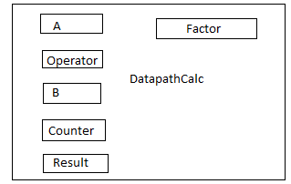

**Consider we are designing for a 4 digit Calculater. So Limit=4 and Counter is a 2-bit register. Max value in 4-digits is 9999, and it requires log2(9999)= 14-bits. So; A,B and Result are 14-bit registers. Operator is a 4-bit register. Factor is a 10-bit register initialized to 1 on Reset.**

**Accumulate Operation is (When ReadA=1)**

**A<=A+Code*factor**

**factor<=factor*10**

* **Combine the Control and Datapath.**

**Submission details**

* **Your lab report, a .doc file, should contain properly commented Post-Lab task code, with Screenshots(of print preview) of Schematic and waveforms, and Critical Analysis.**
* **The report must have a title page in the pescribed format.**
* **Name the .doc file RegNo.docx; eg SP14-BCE-99.docx**
* **Sumbit on portal.**